**Techniques for improving software productivity**

**Exercise 2 - Alloy & CBMC**

**Part 1 – CBMC:**

**add_numbers.c**

**The command used:**

cbmc add_numbers.c --function add_numbers --signed-overflow-check --trace

**Errors:**

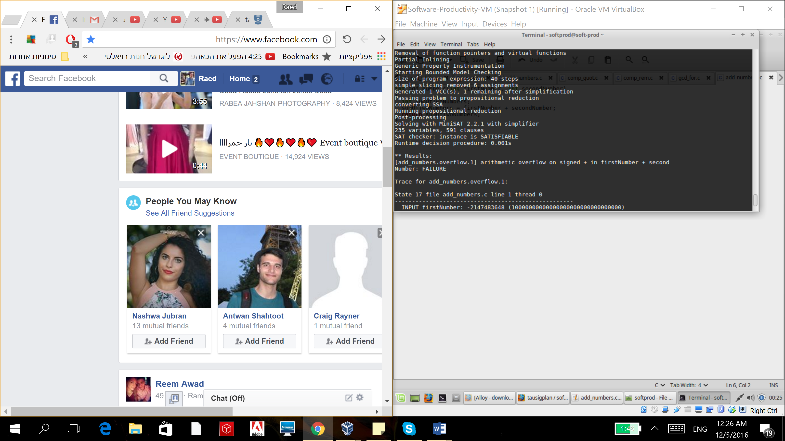

**Fixes:**

1. Changing the function parameters ,since the firstNumber and secondNumber are not defined within the scope of the function.

2. Handling integer overflow, by checking whether adding the given numbers would lead to an overflow.

**Fixed code:**

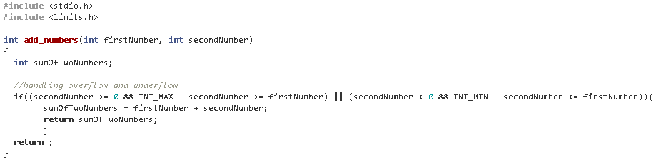

**Array_access.c :**

**The command used:**

cbmc array_access.c --function access --unwind 10 --bounds-check --trace

**Errors:**

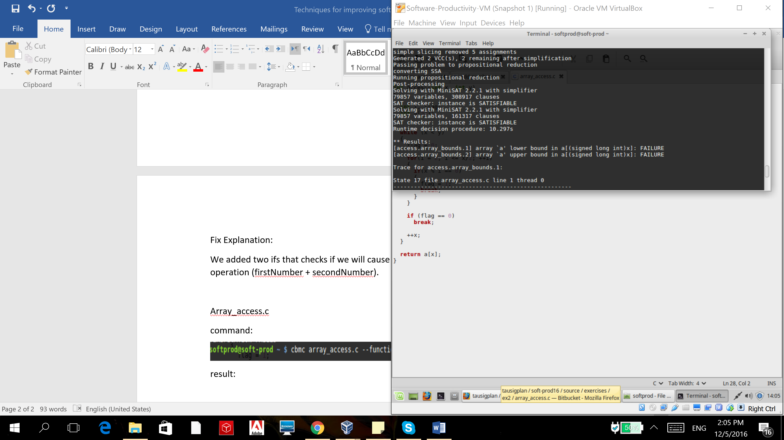

**Fixes:**

Bounds check: checking before the array access whether x is within a valid range or not. So the lower bound of the array (which is 0) and the upper bound (which is 32) won’t be crossed.

**Fixed code:**

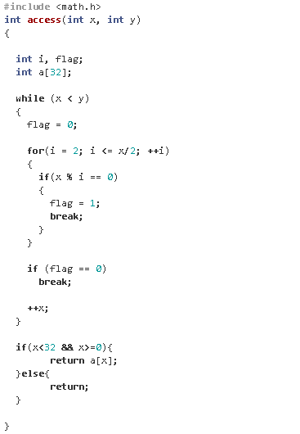

**comp_quot.c:**

**The commands used:**

cbmc comp_quot.c --function compute_quotient --div-by-zero-check --trace

cbmc comp_quot.c --function compute_quotient --signed-overflow-check --trace

**Errors:**

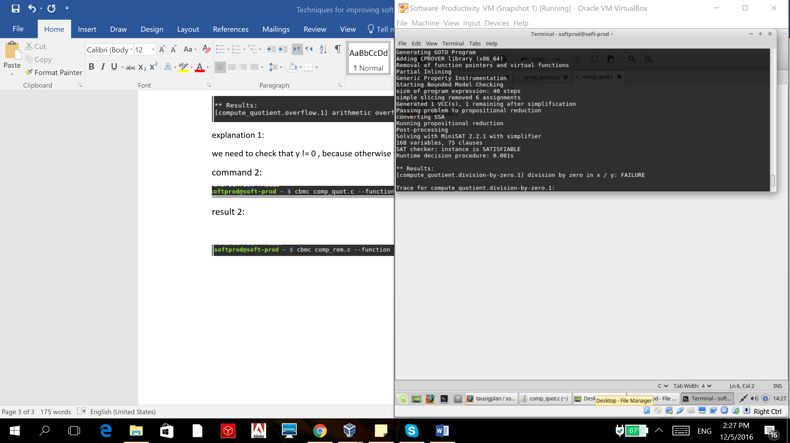

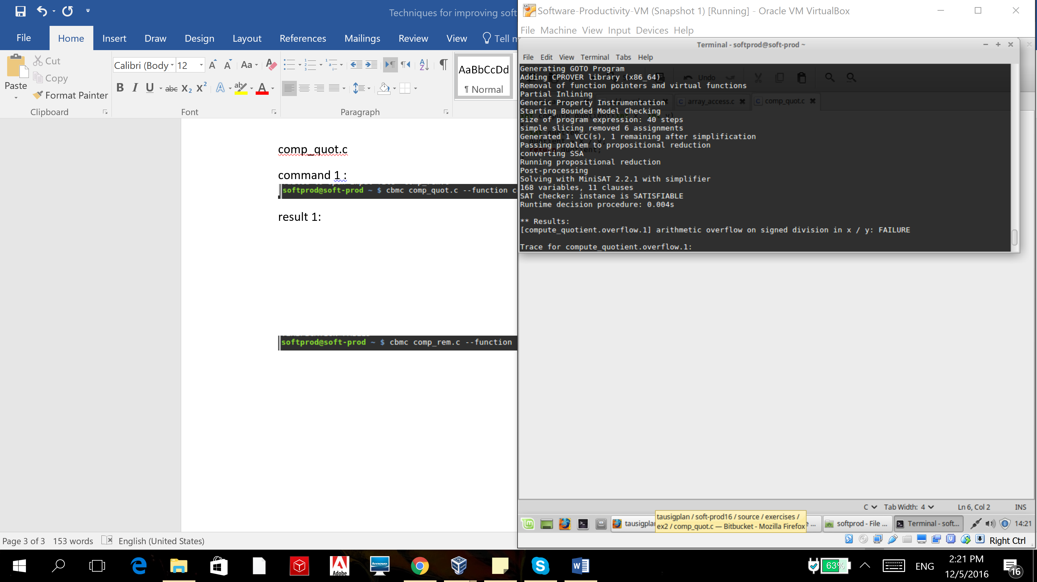

**Fixes:**

1. Check that y unequal to zero.

2. Handling overflow on signed division: by Checking x != -2147483648 or y != -1, so an overflow wouldn’t occur.

**Fixed code:**

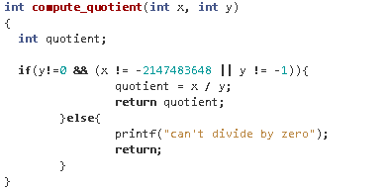

**comp_rem.c:**

cbmc comp_rem.c --function compute_remainder --div-by-zero-check –trace

**Errors:**

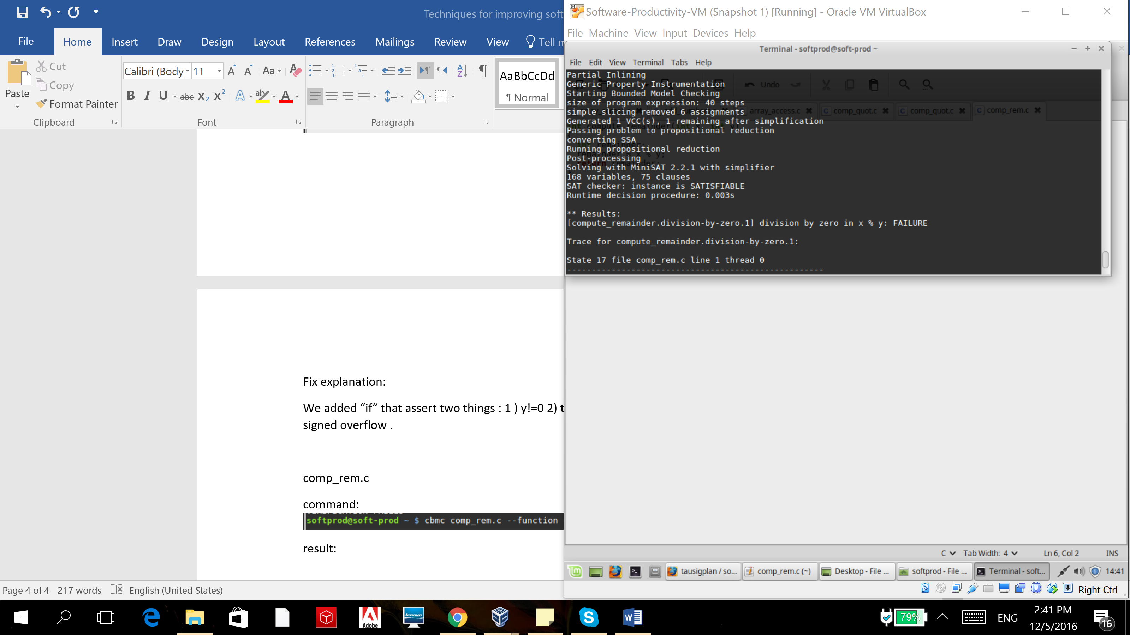

**Fixes:**

Check that y unequal to zero.

**Fixed code:**

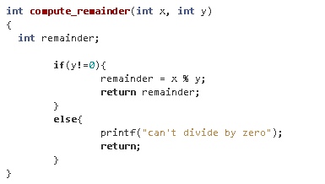

**gcd_for.c:**

cbmc gcd_for.c --function gcd --unwind 10 --signed-overflow-check --unsigned-overflow-check --trace

**Errors:**

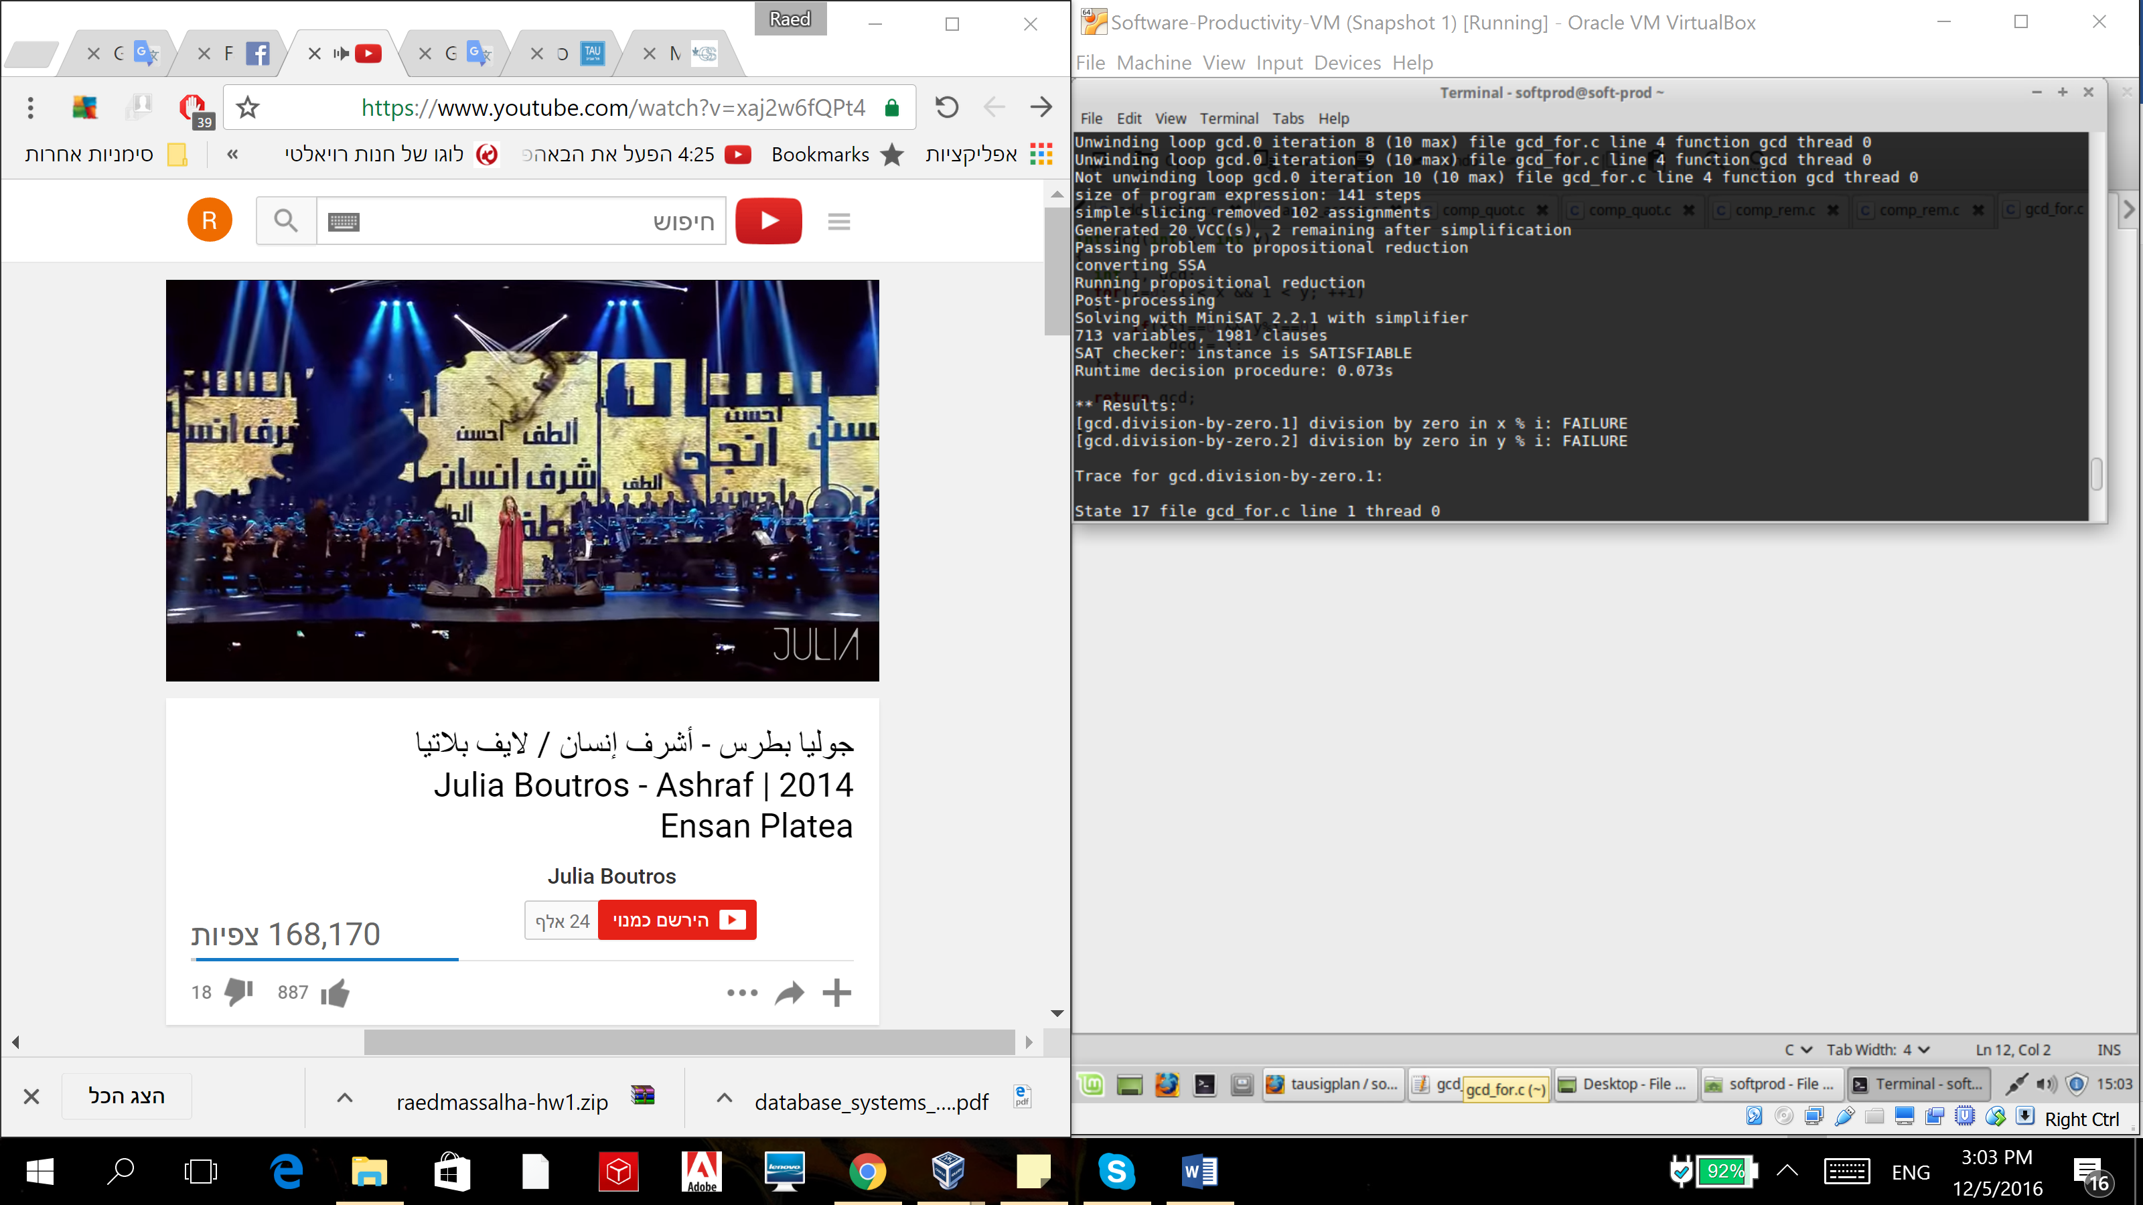

**Fixes:**

Starting the for loop with i=1 instead of i=0 (to avoid division by 0).

**Fixed code:**

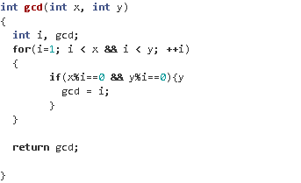

**gcd_while.c:**

cbmc gcd_while.c --function gcd --unwind 10 --signed-overflow-check --trace

**Errors:**

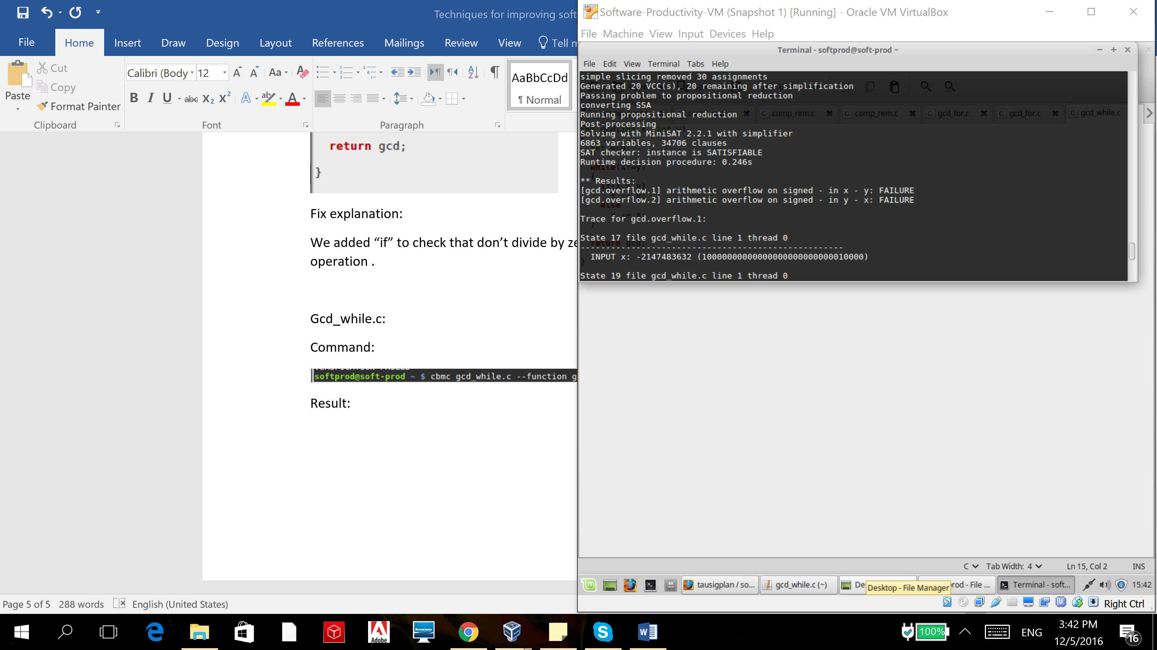

**Fixes:**

Adding check cases for when there may be an integer overflow.

**Fixed code:**

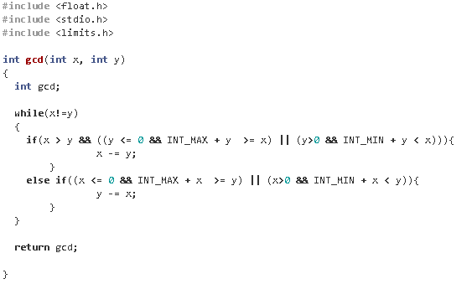

**reverse.c:**

cbmc reverse.c --function reverse --unwind 10 --signed-overflow-check --trace

**Errors:**

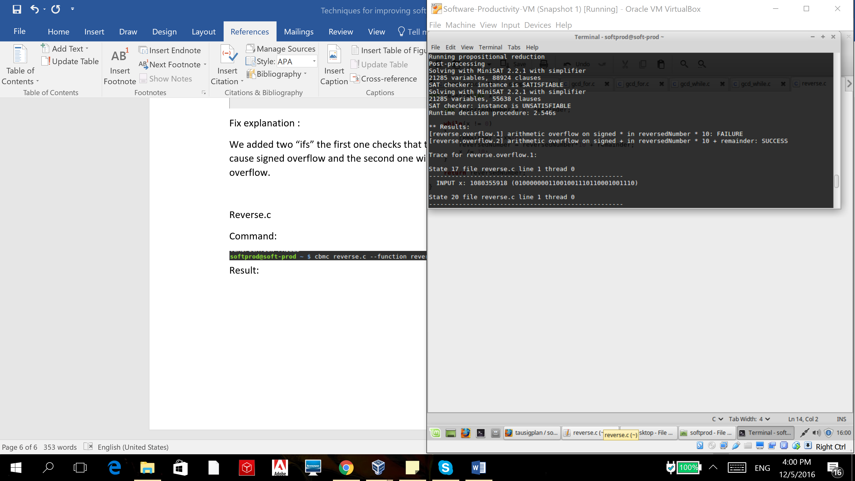

**Fixes:**

Adding if clauses for checking the sign of the reversedNumber and if it’s not “close” to INT_MAX or INT_MIN (according to the sign). otherwise we won’t multiple by 10.

**Fixed code:**

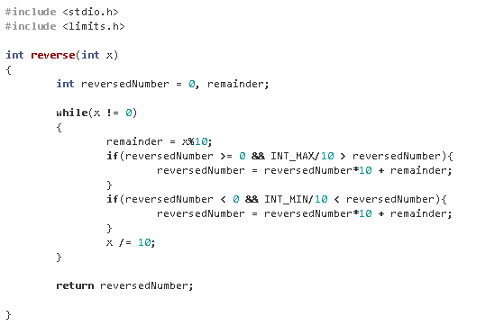

**Swap.c:**

cbmc swap.c --function swap --float--overflow--check --trace

cbmc swap.c --function swap --nan--check --trace

**Errors:**

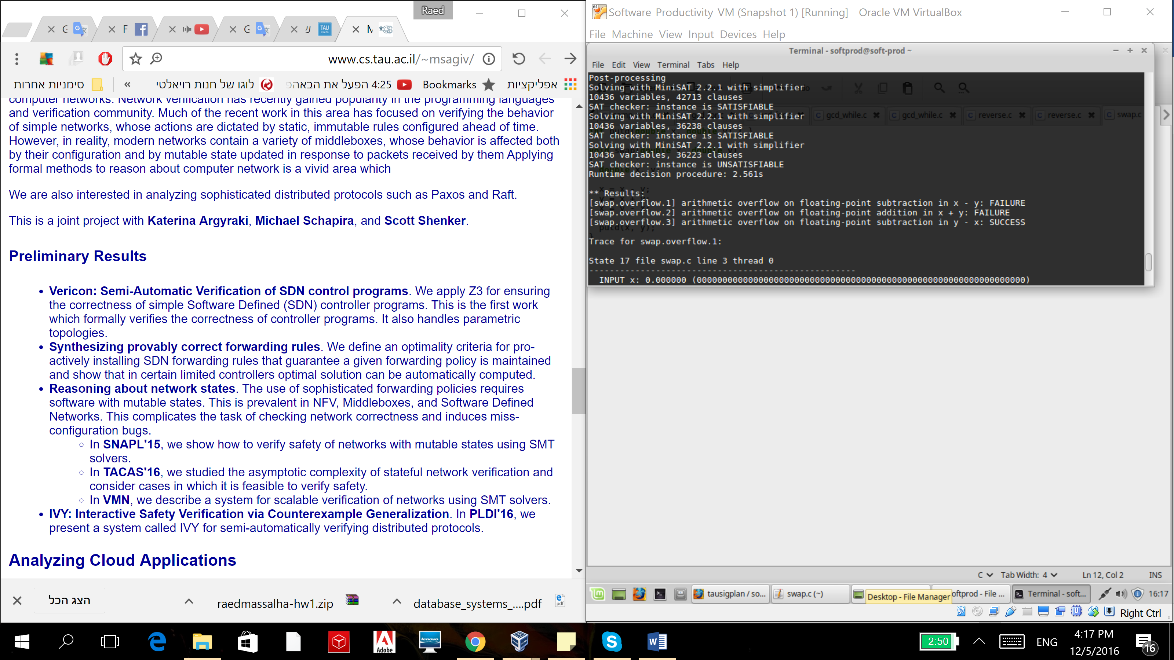

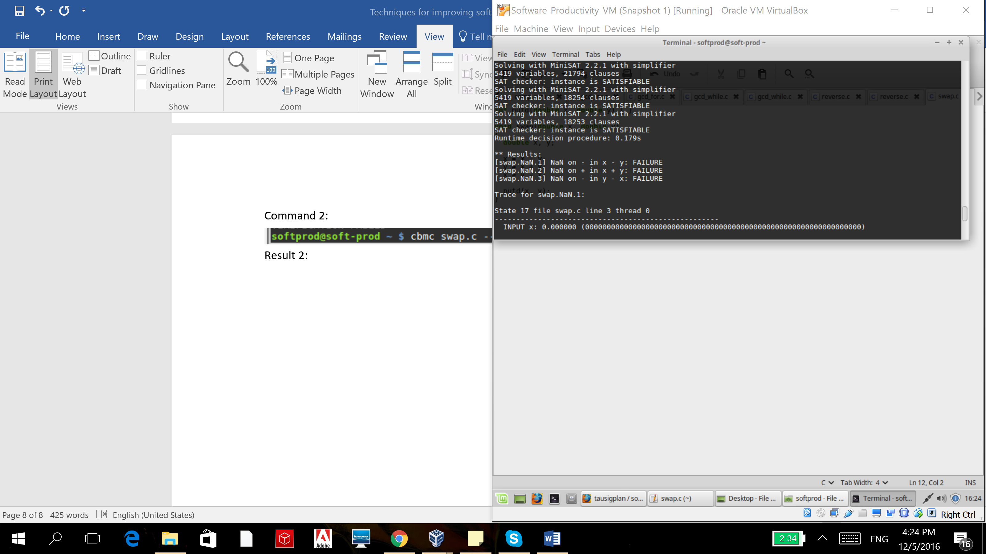

**Fixes:**

1. checking that the variables are numerable.
2. checking that the arithmetic operations will not cause a float overflow.

**Fixed code:**

